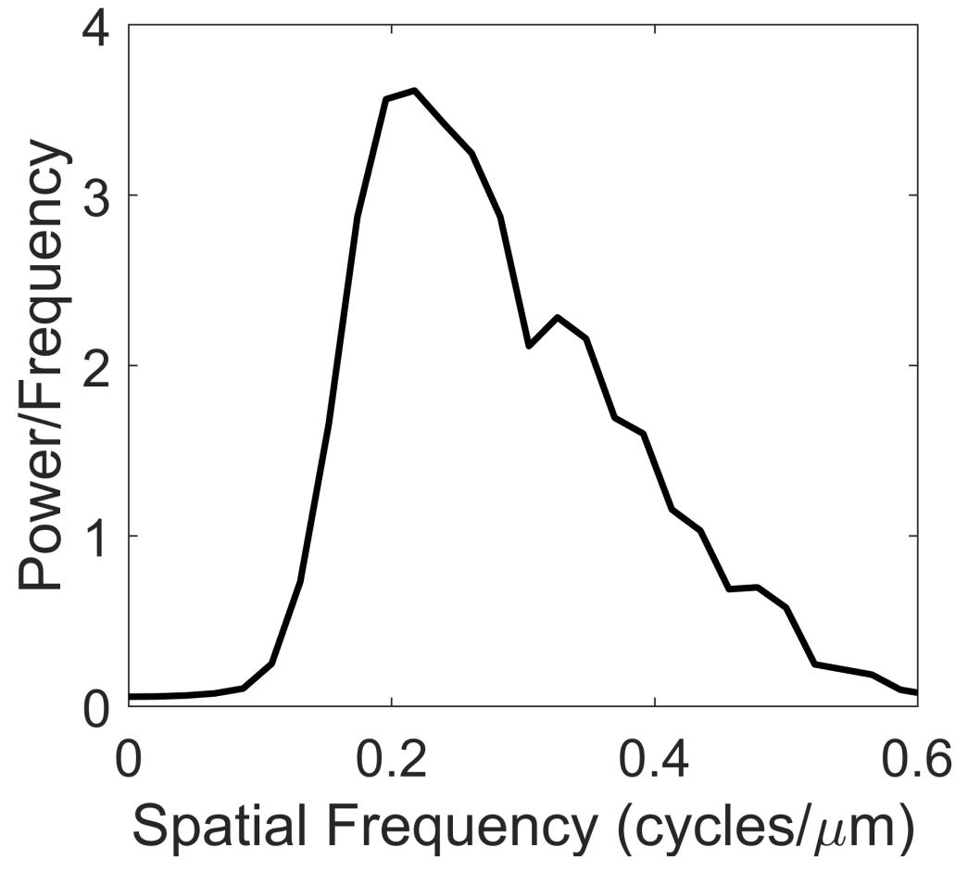

**S6 Fig. Representative power spectral density of the Rac1 activity.** The plot shows the average power spectral density (PSD) of the filtered Rac1* intensity matrix ($I_{{Rac1}^{*}}$ ​) across spatial frequencies for one typical cell, chosen to represent the general behavior observed across multiple cells. The y-axis represents the power per unit frequency, in the units of ${(a.u.)}^{2}/cycles per micrometer$. The x-axis denotes the spatial frequency in cycles per micrometer. The concentration of power at low spatial frequencies suggests that noise in the system is dominated by large-scale spatial fluctuations. Higher spatial frequencies show a rapid decay in power, indicating reduced noise at smaller spatial scales. For the details of calculation, see Materials and methods section Noise analysis of the Rac1* signal.